**Add Icon To App**

**Reference Link :** [**https://www.youtube.com/watch?v=_hgsAlPTGXY&ab_channel=CodeWithAbdul**](https://www.youtube.com/watch?v=_hgsAlPTGXY&ab_channel=CodeWithAbdul)



**Step 1**

Create React Native Project

>>> npx react-native init SplashScreen_CustomIcon_08



**Step 2**

Create application Icon Bundle

<https://icon.kitchen/i/H4sIAAAAAAAAA6tWKkvMKU0tVrKqVkpJLMoOyUjNTVWySkvMKU6t1VHKzU8pzQHJRisl5qUU5WemKOkoZeYXA8ny1CSl2FoApT8%2BHkAAAAA%3D>

You can create your custom icon for free

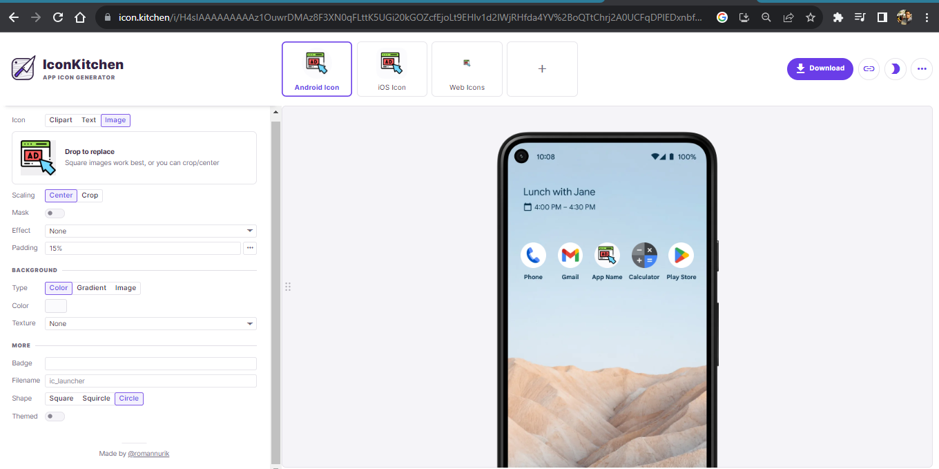

And download

**Step 3**

Unzip the downloaded bundle

And see icons are generated for android ios and web

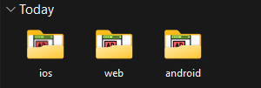

Open android folder folder

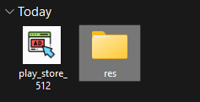

Open src and copy all minmap folder except **mipmap-anydpi-v26**

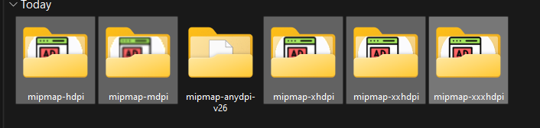

**Step 4**

Open Vs code and navigate

Android -> app -> src -> main -> res

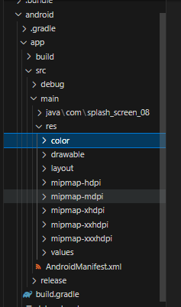

Replace all Minmap folder with downloaded icons

Open res path in folder

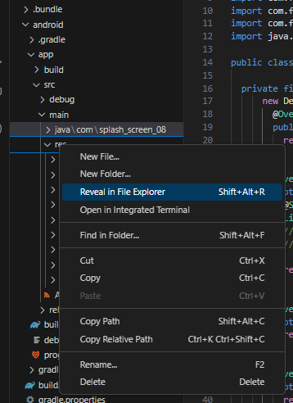

Delete Existing mipmap and paste copied

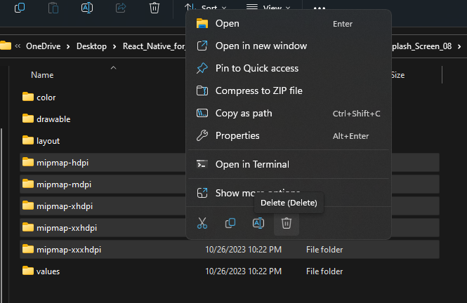

**Step 5**

Goto **android Manifest.xml**

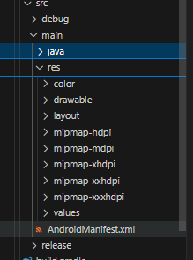

Open AndroidManifes.xml and remove

android:roundIcon="@mipmap/ic_launcher_round"

Line no 9

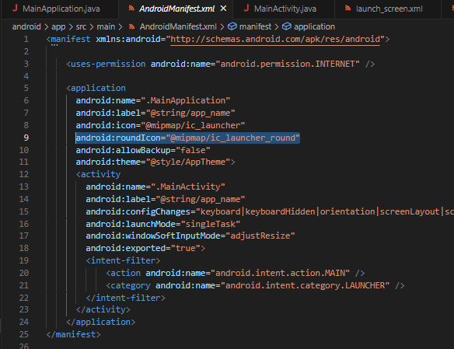

Now Start the app

>>> npx react-native start



App Icon Implemented successfully